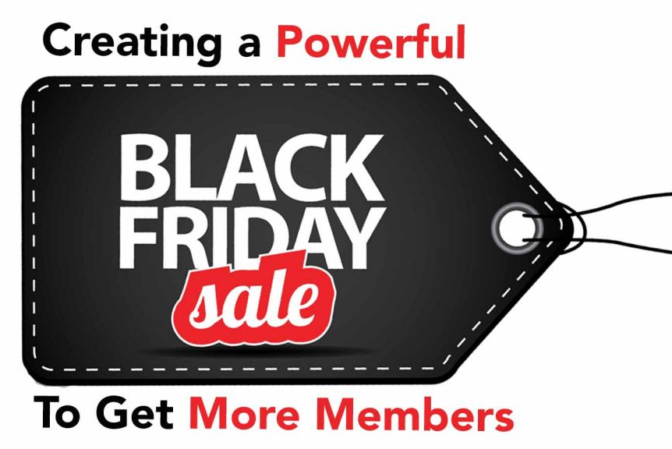

Wednesday, Nov. 25th - Black Friday Preview

Subject - before you head out

Hey John,
Real quick… before you leave for Thanksgiving I wanted you to have a sneak peak at our annual Black Friday Sale.
Get a sneak peak here - www.MembershipMultipliers.com/thanksgiving



If you’re like me, you’re going to be spending time with your family and friends, so I don’t want you to miss out on the opportunity to multiply, launch and market your membership.
Happy thanksgiving!
Scott Whitaker,
Author & Founder of Membership Multipliers
www.MembershipMultipliers.com/thanksgiving

Thursday, Nov. 26th - Big Announcement

Subject - can you microwave a turkey?

Hey John,
How long do you microwave a turkey?
That's the text message my "adulting" 21-year old daughter sent my wife? (Below is a screenshot)

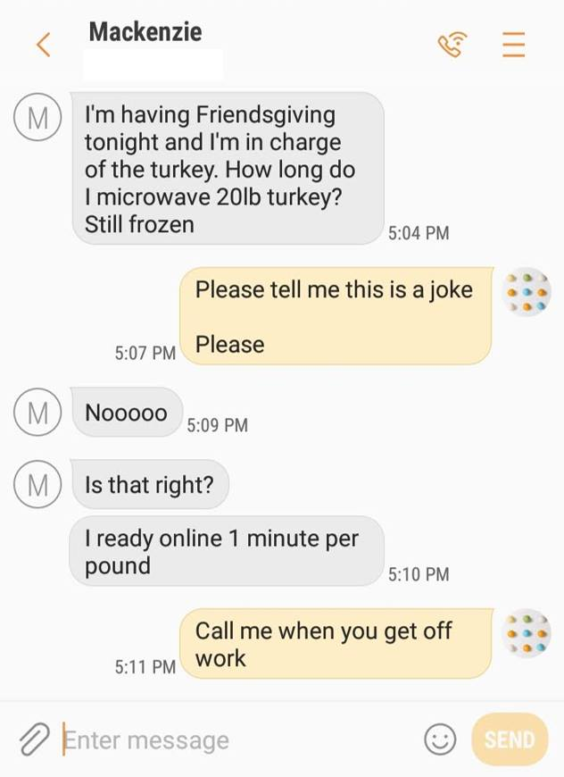

Needless to say, I was grateful to find out it was just an internet joke.
However, that's well after my wife and I began questioning our parenting skills. (At least we have her younger sister to get it right the second time around!)
So, as you celebrate your thanksgiving (with a turkey that is fully cooked, I hope), I wanted to share with you the 10X Membership Package Thanksgiving Sale going on.
Now through Monday, this is THE COMPLETE PACKAGE to help you launch, multiply and market your membership. You get three resources and save over $1094.00!
Get the 10X Membership Package Thanksgiving Sale at the link below:
www.membershipmultipliers.com/thanksgiving
Make an investment in your membership business today and :
Multiply Your Membership with the "4-Day Membership Generator"
- SIMPLE, PROVEN, STEP-BY-STEP instructions and literally use fill-in-the-blank templates
- Generates thousands of dollars in membership in just 96 hours
- Based on a powerful psychological methodology that, through email, turns uninterested prospects into ravenous members
You Can Launch With The Membership Power Launch
- ​21 Day Launch Plan that will walk you through every step of launching your membership from scratch
- The simple way to get paid for membership without being tech savvy. (We literally show you how to set everything up!)
- How to build your content and services (using the expertise of other people.)
Market Your Membership with "Marketing Your Membership on Facebook for Free"
- How to get Facebook to market your membership for you for free!
- The ten different ways you can get more likes, shares, comments and get prospects to action
- The one simple trick that will get you more prospects, so simple, you'll think "why didn't I think of that!"
Plus you'll get the "Ultimate Social Post Media Checklist" as a bonus!
Tami Santini told me, "​​I have a plan! There is such freedom and peace in knowing that what I am doing will provide an amazing opportunity for others as well as great wealth!"
Whether you're just starting your membership or you're a seasoned veteran, you're going to get the tools you need so that you can MULTIPLY YOUR MEMBERS and YOUR MONEY.
If you're ready to multiply your membership, help more people, and make more money, click the link below:
www.membershipmultipliers.com/thanksgiving
Now time for me to go check the microwave and see if the turkey is ready.
Have a Happy Thanksgiving!
Scott

P.S. I'll take on all the risk. If this membership package doesn't work, simply let me know and I'll give you a prompt and courteous refund. If my tools don't fit your toolbox, then I don't want you to have them.
How can I make this promise? Because I'm confident that you will be able to multiply your membership and your money using these simple tools.
But you must hurry! This opportunity ends midnight, Monday, December 2nd.
>>Click here and save over $1,094.00 now!

Scott Whitaker,
Author & Founder of Membership Multipliers

Friday, Nov. 27th - Black Friday

Subject - 10x your membership

Hey John,
Well, it's happening again.
The Black Friday madness has begun.
People rushing stores...
Trampling over one another and store employees...
Only to get the latest toy or gadget for their shopping list.
Instead of leaving your home, why not do something for yourself and your membership business.
Something that actually puts money back in your pocket.
Something that enables you to help more people with your membership.
Now through Monday, you can save over $1,094.00 on the "10X Membership Package Thanksgiving Sale."
If you're looking to multiply your membership business and help more people, then this is the membership package to get it done!
www.MembershipMultipliers.com/thanksgiving
Make an investment in your membership business today and:
Multiply Your Membership with the "4-Day Membership Generator"
- SIMPLE, PROVEN, STEP-BY-STEP instructions and literally use fill-in-the-blank templates
- Generates thousands of dollars in membership in just 96 hours
- based on a powerful psychological methodology that, through email, turns uninterested prospects into ravenous members
You Can Launch With The Membership Power Launch
- ​21 Day Launch Plan that will walk you through every step of launching your membership from scratch
- The simple way to get paid for membership without being tech savvy. (We literally show you how to set everything up!)
- How to build your content and services (using the expertise of other people.)
Market Your Membership with "Marketing Your Membership on Facebook for Free"
- How to get Facebook to market your membership for you for free!
- The ten different ways you can get more likes, shares, comments and get prospects to action
- The one simple trick that will get you more prospects, so simple, you'll think "why didn't I think of that!"
Plus you'll get the "Ultimate Social Post Media Checklist" as a bonus!
Whether you're just starting your membership or you're a seasoned veteran, you're going to get the tools you need so that you can MULTIPLY YOUR MEMBERS and YOUR MONEY.
It really is possible to go from adding members to multiplying your membership. You just need a proven membership package to make it happen.
If you're ready to multiply your membership and help more people, click the link below:
www.MembershipMultipliers.com/thanksgiving
Let's multiply your membership!
Scott

P.S. I'll take on all the risk. If this membership package doesn't work, simply let me know and I'll give you a prompt and courteous refund. If my tools don't fit your toolbox, then I don't want you to have them.
How can I make this promise? Because I'm confident that you will be able to multiply your membership using this simple toolkit.
But you must hurry! This opportunity ends midnight, Monday, December 2nd.
>>Go here to 10X your membership now!
Do something that puts money back in your pocket unlike…



Scott Whitaker,
Author & Founder of Membership Multipliers

Sunday, Nov. 29th - (Optional)

Subject - falling Christmas tree

Hey John,
If a Christmas tree falls in a living room, does it make a sound?
One Black Friday,, when I woke up and went down to our living room, there it was.
Lying on the floor, broken branches, pine needles everywhere with a mixture of water and pine sap spilled on the floor.
Our Christmas tree fell and no one in the family heard it. Luckily, we were too tired from Black Friday to put the lights and ornaments on it last night.

In your business, you’ve probably experienced the same thing.
You open your email or walk into the office and there's an unexpected mess waiting for you to clean it up.
It can range from:
- Unhappy members complaining about their membership
- Drop in retention rate due to an increase in cancellations
- Lack of new members signing up and you're going to miss your goal
- Marketing not working and bringing you the number of leads you need
The list can go on.
All just waiting for you to clean it up.
That's why I'm extending the Thanksgiving Sale through Cyber Monday.
www.MembershipMultipliers.com/thanksgiving
There's no reason for you to go at it alone.
Do something that actually puts money back in your pocket.
Something that enables you to help more people with your membership.
Now through Monday, you can save over $1,094.00 on the best-selling "10X Membership Package Thanksgiving Sale."
If you're looking to multiply your membership business and help more people, then this is the membership package to get it done!
Make an investment in your membership business today and:
Multiply Your Membership with the "4-Day Membership Generator"
- SIMPLE, PROVEN, STEP-BY-STEP instructions and literally use fill-in-the-blank templates
- Generates thousands of dollars in membership in just 96 hours
- based on a powerful psychological methodology that, through email, turns uninterested prospects into ravenous members
You Can Launch With The Membership Power Launch
- ​21 Day Launch Plan that will walk you through every step of launching your membership from scratch
- The simple way to get paid for membership without being tech savvy. (We literally show you how to set everything up!)
- How to build your content and services (using the expertise of other people.)
Market Your Membership with "Marketing Your Membership on Facebook for Free"
- How to get Facebook to market your membership for you for free!
- The ten different ways you can get more likes, shares, comments and get prospects to action
- The one simple trick that will get you more prospects, so simple, you'll think "why didn't I think of that!"
Plus you'll get the "Ultimate Social Post Media Checklist" as a bonus!
Whether you're just starting your membership or you're a seasoned veteran, you're going to get the tools you need so that you can MULTIPLY YOUR MEMBERS and YOUR MONEY.
If you're ready to multiply your membership and help more people, click the link below:
www.MembershipMultipliers.com/thanksgiving
Let's multiply your membership!
Scott
P.S. I'll take on all the risk. If this membership package doesn't work, simply let me know and I'll give you a prompt and courteous refund. If my tools don't fit your toolbox, then I don't want you to have them.
How can I make this promise? Because I'm confident that you will be able to multiply your membership using this membership package.
But you must hurry! This opportunity ends midnight, Monday, December 2nd.
>>Go here and let’s 10X your membership!
Scott Whitaker,
Author & Founder or Membership Multipliers

Monday, Nov. 30th - Cyber Monday (Morning)
Subject - launch, multiply, grow (video enclosed)

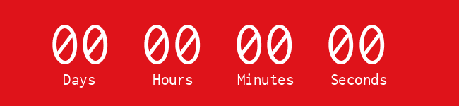
Hey John,
Real quick...midnight tonight is your last chance to launch, multiply and market your membership with proven templates, strategies and swipe files.
These are the same tools that I use in my own membership business and that my Membership Multipliers are using too.
You can save over $1,094.00 on the best-selling "10X Membership Package Thanksgiving Sale."
There's no reason for you to go at it alone.
If you're looking to multiply your membership and help more people, then the 10X Your Membership Package will get it done!

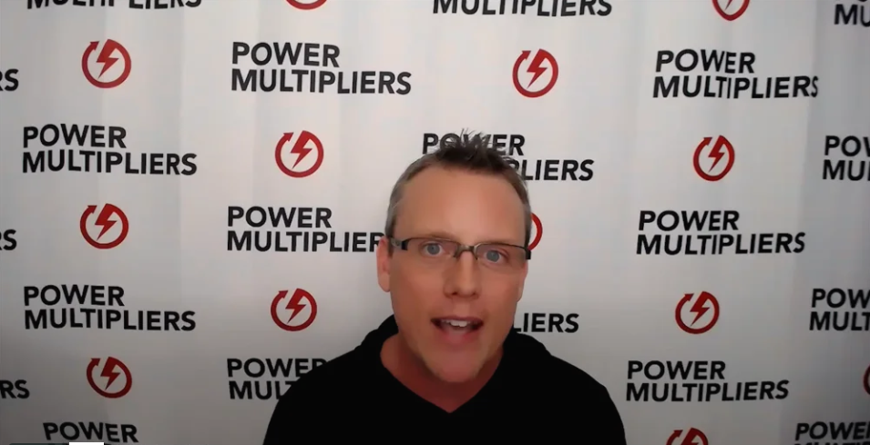
www.MembershipMultipliers.com/thanksgiving
Make an investment in your membership business today and:
Multiply Your Membership with the "4-Day Membership Generator"
- SIMPLE, PROVEN, STEP-BY-STEP instructions and literally use fill-in-the-blank templates
- Generates thousands of dollars in membership in just 96 hours
- based on a powerful psychological methodology that, through email, turns uninterested prospects into ravenous members
You Can Launch With The Membership Power Launch
- ​21 Day Launch Plan that will walk you through every step of launching your membership from scratch
- The simple way to get paid for membership without being tech savvy. (We literally show you how to set everything up!)
- How to build your content and services (using the expertise of other people.)
Market Your Membership with "Marketing Your Membership on Facebook for Free"
- How to get Facebook to market your membership for you for free!
- The ten different ways you can get more likes, shares, comments and get prospects to action
- The one simple trick that will get you more prospects, so simple, you'll think "why didn't I think of that!"
Plus you'll get the "Ultimate Social Post Media Checklist" as a bonus!
Whether you're just starting your membership or you're a seasoned veteran, you're going to get the tools you need so that you can MULTIPLY YOUR MEMBERS and YOUR MONEY.
If you're ready to multiply your membership and help more people, click the link below:
www.MembershipMultipliers.com/thanksgiving
Let's multiply your membership!
Scott
P.S. I'll take on all the risk. If this membership package doesn't work, simply let me know and I'll give you a prompt and courteous refund. If my tools don't fit your toolbox, then I don't want you to have them.
How can I make this promise? Because I'm confident that you will be able to multiply your membership using this membership package.
But you must hurry! This opportunity ends midnight tonight, Monday, December 2nd.
>>Go here and let’s 10X your membership!
Scott Whitaker,
Author & Founder or Membership Multipliers

Monday, Nov. 30th - Cyber Monday(Afternoon)
Subject - just a few more hours
Hey John,
In just a few more hours, the doors are closing on the "10X Membership Package."
This is a crazy awesome, once in a lifetime opportunity that we want you to be part of...
It's waiting for you...
The single best package to launch and multiply your membership...
www.MembershipMultipliers.com/thanksgiving
HURRY... this opportunity ends tonight at midnight!
Save over $1,094.00 on the best-selling resource.
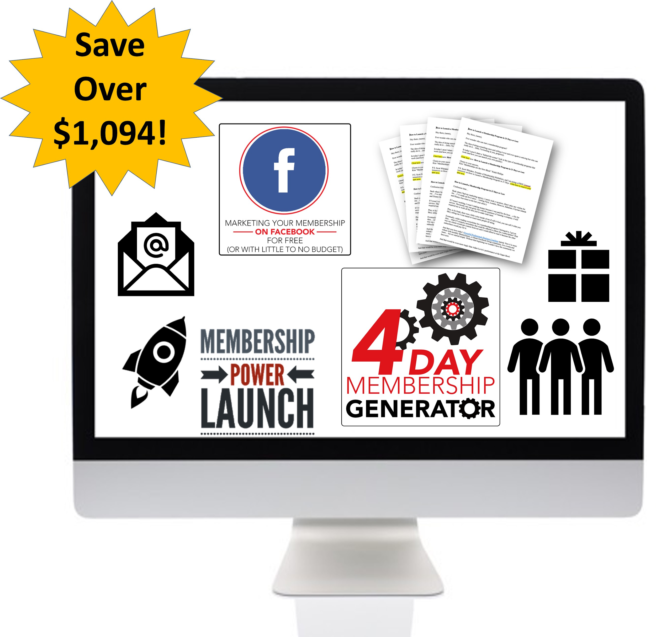
This is the single BIGGEST discount we've ever run EVER!
Check out all the details here before midnight tonight.
www.MembershipMultipliers.com/thanksgiving
Let's multiply your membership!
Scott
P.S. I'll take on all the risk. If this membership package doesn't work, simply let me know and I'll give you a prompt and courteous refund. If my tools don't fit your toolbox, then I don't want you to have them.
How can I make this promise? Because I'm confident that you will be able to multiply your membership using this membership package.
But you must hurry! This opportunity ends midnight tonight, Monday, December 2nd.
>>Go here and let’s 10X your membership!
Scott Whitaker,
Author & Founder or Membership Multipliers

