

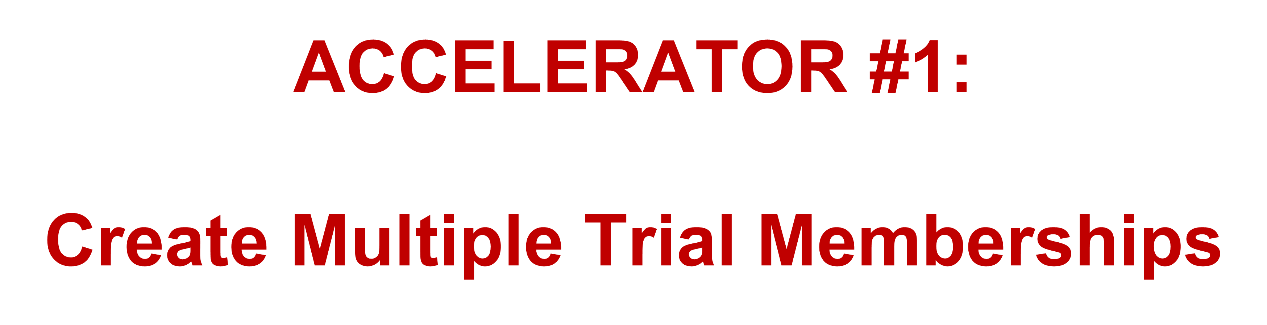
How?

Type of Offer
Length of Opportunity
Options

Examples:
- Free trial for X days for just $
- Just pay $ for X days
- Get [] free when you sign up for just $
- Buy [] and get membership free for X days

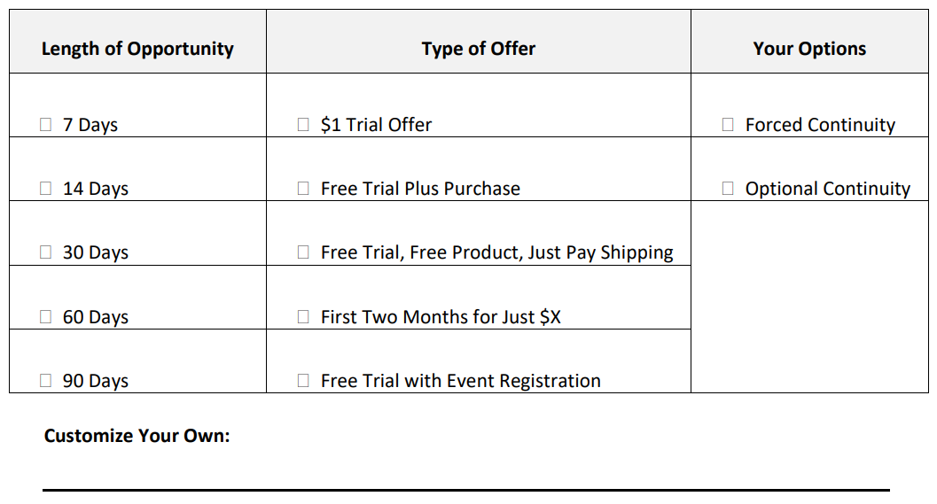
Trial Membership Creation Cheat Sheet

I will complete this on ____________________________________.
(Date)

“Two-Day Membership Blitz” is a focused email campaign where you make an outrageous offer to join your membership program.

Email #1: Send early in the day
Announcing the opportunity

Email #2: Send early evening the same day

Email #3: Send the day after early in the day
Ends today

Email #4: Send the same day ending the blitz
Ends at midnight

I will complete this on ____________________________________.
(Date)
Two-Day Membership Blitz Example Emails
4 Weeks for $4 - Birthday Sales Series
EMAIL#1
SUBJECT: your birthday facts
SEND – Morning Day Before

Have you ever considered who was the first person to celebrate their birthday?
If you think about it, we should all be grateful for that person. Imagine people getting the first birthday invitation to celebrate the day of someone's birth. HA!
We'll never know who that person was, but here are five fun facts about birthdays:
- Egyptians celebrated birthdays for their gods.
- The Greeks were the first to add candles to a cake to celebrate.
- The Romans were the first to celebrate birthdays for common people.
- Contemporary birthday cakes were invented by German bakers.
- The "Happy Birthday" song was a remix of "Good Morning to All"
So, why all the birthday fun facts?
Well, today is my 44th birthday!
And to celebrate, my team thought it would be a fun gesture to give you a test-drive of the Membership Accelerators Club - 4 weeks for $4.
See what they did: 4 - 4! I wasn't too sure about sharing my age, but I decided if it gives us an opportunity to help you and your members why not.
Click the link below to find out more:
www.MembershipMultipliers.com/44

https://big.assets.huffingtonpost.com/cake1.gif

Here's everything you'll receive with your 4 weeks for $4:
- Marketing Your Membership on Facebook for FREE to enable Facebook to promote your membership and create a prospect avalanche to get more members in the next four weeks than you have the last four months
- Uncovering Your IPM (even if you don't know what an IPM is) so that I'll know who are my best prospects and get them to take my membership
- A copy of my brand-new book, "Accelerate: How to Get Your Next 10, 100, 500 or Even 1,000 Members"
- Private Facebook Group where you can meet other membership marketers and exchange ideas and gain more insight
But you must sign up before midnight, Thursday, June 27th.
Click here now: www.MembershipMultipliers.com/44
What can I say, I like to celebrate my birthday for two days?
Maybe, I'll start a trend and everyone will start celebrating their birthday for two days. HA!
Happy birthday to me!
Scott
P.S. One last thing, in all seriousness, I'm also raising funds for Compassion International to help expectant moms and mothers of newborns to provide for the care of their babies. Click here to donate to the cause!
P.P.S. If you sign up for the Membership Accelerators Club, I'm going to make a donation in your honor. I'll be doing it for all the members of the Membership Accelerators Club. So you can actually make two contributions, donate here and become a Membership Accelerator at the link below:
www.MembershipMultipliers.com/44
Get your 4 weeks for $4 now!

Scott Whitaker,
Founder of Membership Multipliers

EMAIL#2
SUBJECT: 4 weeks for $4
SEND – Evening Day Before

Hey, John Donahue here, Dir of Marketing for Scott Whitaker and Membership Multipliers.
I've just taken over the place and wanted to send you an email from Scott's email address.
Don't say anything. I think he's in a sugar coma from all the birthday cake anyway.
You may have seen that Scott is turning 44 today. Feel free to reply and wish him a "Happy Birthday"
But also, I thought it would be a great opportunity for you to get 4 weeks of the Membership Accelerators Club for just $4. (He's turning 44 - 4 for 4, see what I did there!)
Click the link below to find out more:
www.MembershipMultipliers.com/44

Here's everything you'll receive with your 4 weeks for $4:
- Marketing Your Membership on Facebook for FREE to enable Facebook to promote your membership and create a prospect avalanche to get more members in the next four weeks than you have the last four months
- Uncovering Your IPM (even if you don't know what an IPM is) so that I'll know who are my best prospects and get them to take my membership
- A copy of my brand-new book, "Accelerate: How to Get Your Next 10, 100, 500 or Even 1,000 Members"
- Private Facebook Group where you can meet other membership marketers and exchange ideas and gain more insight
But you must sign up before midnight, Thursday, June 27th.
Click here now: www.MembershipMultipliers.com/44
Happy birthday to Scott!
John
P.S. Here's to hoping I don't get fired. However, with the number of people who have already signed up for the 4 for $4, I don't think that will happen. Get your 4 weeks for $4 now:
www.MembershipMultipliers.com/44

John Donahue,
Dir of Marketing,
Membership Multipliers

EMAIL#3
SUBJECT: gift for you (pic enclosed)
SEND – Morning Day Of

Hey John,
I've got a package for you! (See the pic below.)
It's actually a "reverse birthday gift!"
You may have heard that yesterday was my birthday. I leveled up to 44.
And to celebrate, my team thought it would be a fun gesture to give you a test-drive of the Membership Accelerators Club - 4 weeks for $4.
So, what's in the "birthday gift" I've got for you? Keep reading or click the link below to find out more:
www.MembershipMultipliers.com/44

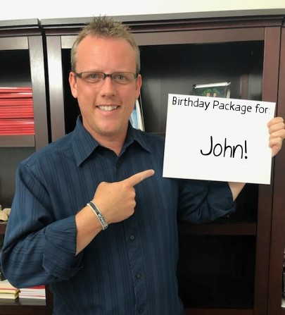

Here's everything you'll receive with your 4 weeks for $4:
- Marketing Your Membership on Facebook for FREE to enable Facebook to promote your membership and create a prospect avalanche to get more members in the next four weeks than you have the last four months
- Uncovering Your IPM (even if you don't know what an IPM is) so that I'll know who are my best prospects and get them to take my membership
- A copy of my brand-new book, "Accelerate: How to Get Your Next 10, 100, 500 or Even 1,000 Members"
- Private Facebook Group where you can meet other membership marketers and exchange ideas and gain more insight
But you must sign up before midnight, TONIGHT, Thursday, June 27th.
Click here now: www.MembershipMultipliers.com/44
Happy day after my birthday!
Scott
P.S. You may have heard that, I'm also raising funds for Compassion International to help expectant moms and mothers of newborns to provide for the care of their babies. Click here to donate to the cause!
We've almost raised $1,000 for Compassion International! If you sign up for the Membership Accelerators Club, I'm going to make a donation in your honor. I'm doing it for all the members of the Membership Accelerators Club. So you can actually make two contributions, donate here and become a Membership Accelerator at the link below:
www.MembershipMultipliers.com/44
Get your 4 weeks for $4 now!

Scott Whitaker,
Founder of Membership Multipliers

EMAIL#4
SUBJECT: the cake is on fire (see inside)
SEND – Late Afternoon Day Of
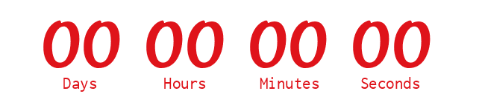
(Countdown clock to midnight)

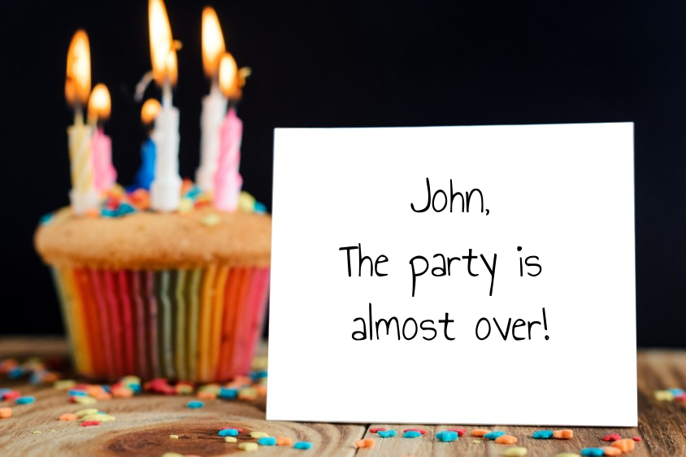

It's time to blow out the candles.
The "reverse birthday gift" is set to go away. Like all great parties, somebody's got to call it to an end!
So, be sure to get your Membership Accelerators Club - 4 weeks for $4 before MIDNIGHT!
www.MembershipMultipliers.com/44

Here's everything you'll receive with your 4 weeks for $4:
- Marketing Your Membership on Facebook for FREE to enable Facebook to promote your membership and create a prospect avalanche to get more members in the next four weeks than you have the last four months
- Uncovering Your IPM (even if you don't know what an IPM is) so that I'll know who are my best prospects and get them to take my membership
- A copy of my brand-new book, "Accelerate: How to Get Your Next 10, 100, 500 or Even 1,000 Members"
- Private Facebook Group where you can meet other membership marketers and exchange ideas and gain more insight
But you must sign up before midnight, TONIGHT, Thursday, June 27th.
Click here now: www.MembershipMultipliers.com/44
Now, it's time for me come down from this sugar rush!
Scott
P.S. Once the candles burn out and the timer counts down, you will miss out. This opportunity will not be available after midnight Pacific tonight. I believe in integrity and keeping deadlines firm. So be sure to get your 4 weeks for $4 now:
www.MembershipMultipliers.com/44

Scott Whitaker,
Founder of Membership Multipliers



HOW?

- Create an “Ideal 25” List.

Who do you know that can sell YOUR MEMBERSHIP for you?

Who do you know that can GENERATE LEADS to your list for you?

Who do you know that has products or resources
that YOUR AUDIENCE DESIRES TO BUY?

- Develop your relationship with them.
- Ask! (Dig Your Well Before You’re Thirsty by Harvey Mackay)
- Make it a “win-win” opportunity.
Usually 50-50, but can be 60-40.
Could also just be a referral fee.

”Ideal 25” List

1. ________________________________________________________
2. ________________________________________________________
3. ________________________________________________________
4. ________________________________________________________
5. ________________________________________________________
6. ________________________________________________________
7. ________________________________________________________
8. ________________________________________________________
9. ________________________________________________________
10. ________________________________________________________
11. ________________________________________________________
12. ________________________________________________________
13. ________________________________________________________
14. ________________________________________________________
15. ________________________________________________________

16. ________________________________________________________
17. ________________________________________________________
18. ________________________________________________________
19. ________________________________________________________
20. ________________________________________________________
21. ________________________________________________________
22. ________________________________________________________
23. ________________________________________________________
24. ________________________________________________________
25. ________________________________________________________

I will complete this on ____________________________________.
(Date)

