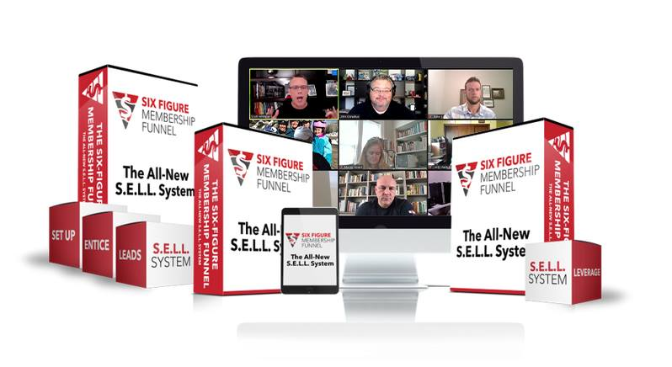

Setup Checklist, Description, Rules, Questions & Templates
Setup Checklist

Day | Goal | Details | Complete?
1 | Create Your Group
2 | Write Your Group Description | See the example in this document
3 | Write Your Group Questions | See the example in this document
4 | Create Your Group Rules | See the example in this document
5 | Customize Your Group | See the example images in this document
6 | Complete “Customizing Your Group”
7 | Add to your personal profile | See the example in this document

Facebook Group Description
Example:
This is the place for membership & association leaders and marketers to get the tools they need to market their membership, increase retention, keep people from quitting and actually multiply their money!
This is a private Facebook Group where you can join by request only.

Template:
This is the place for [who is your ideal prospect] to get [what outcome does your membership provide]!
This is a private Facebook Group where you can join by request only.

Facebook Group Questions
Example:
Question 1
[Step 1 - Required] *Do you have a membership?
Question 2
[Step 2 - Required] *What's your email address? I'll send you a free copy of my Seven Membership Multipliers Strategy Guide.
Question 3
[Step 3 - Required] *One of my members generated 15k in two weeks. Would you like me to send you the program details? [Yes / No] **Check your Private Messages / Message Requests in a day or two**

Facebook Group Rules
Example:
1 – Be Cool
You know Dwayne "The Rock" Johnson? Be cool like that. Totally OK to disagree with someone’s post. Heck, even mine. But never cool to attack a person or be rude. Even sarcasm comes off rude in print.

2 – Peers Not prospects
The people in this group are your peers, not your prospects. Help each other. Serve//Share/Give. No PMing members. Post your links but only with the intent of getting feedback and looking to improve.

3 – This Group is Yours
I made this place for you to ask, to share, to brainstorm — so we can help you grow and scale. Get busy. Ask questions. Post. Comment. Like. The more you put in, the more you’ll get.

4 – This Group is Mine
I want this place to be great for us all. If you do something that goes against a member, this group, or the spirit we’re trying to create... you’ll be booted faster than you can say “I was just..."

Banner Image
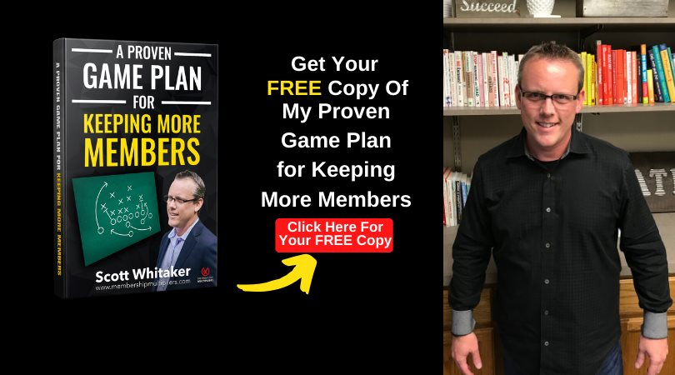

Banner Image – Template
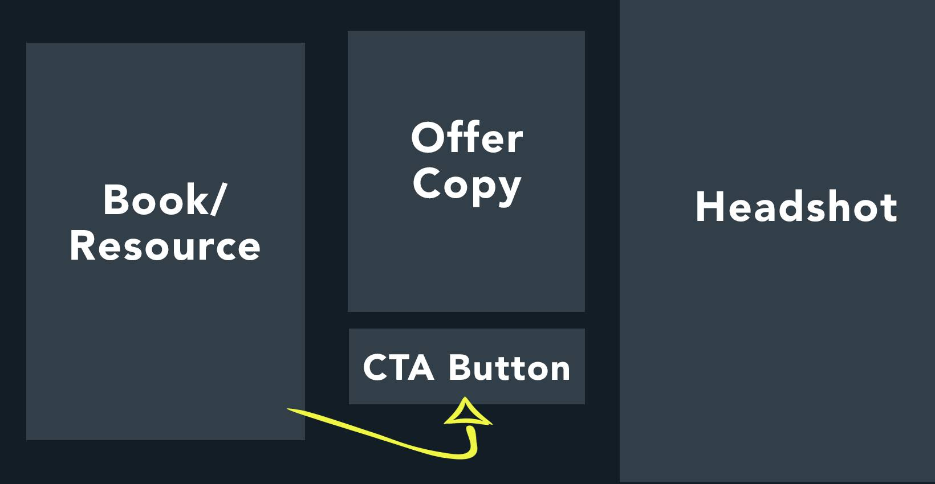

Banner Image - Description
Here is the template that you should use for your group cover photo:
Get a FREE copy of the Seven Membership Multipliers Strategy Guide
Go here to request access and get your free resource -
https://www.facebook.com/groups/SELLsystem
Yes, you can get a free copy of this strategy guide! In it, you discover the seven membership multipliers that exist in every membership, regardless of your niche.
Click here to get your free book now -
https://www.facebook.com/groups/SELLsystem

Personal Profile - Featured Image
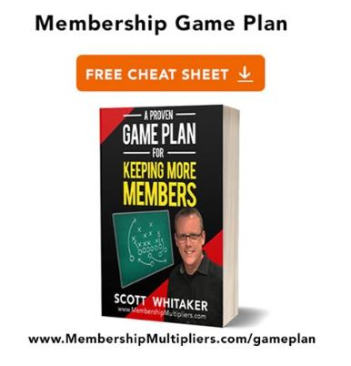
Featured Image - Description
Here is the template that you should use for your group cover photo:
Get a FREE copy of the Seven Membership Multipliers Strategy Guide
Go here to request access and get your free resource -
https://www.facebook.com/groups/SELLsystem
Yes, you can get a free copy of this strategy guide! In it, you discover the seven membership multipliers that exist in every membership, regardless of your niche.
Click here to get your free book now -
https://www.facebook.com/groups/SELLsystem

Upgrading Your Profile
- Use a separate “Business Page” for your membership than your personal “Profile Page”
- On your business page, upgrade your banner image to a “Call to Action”
- Update your “About” section (template further below)
On your personal profile, put your Facebook Group link. Here’s an example from my personal profile.
Multiplying your membership so you can get & serve more members
👉 https://bit.ly/2NTy7JP 👈

- Update your business profile picture to a picture of you (make it a different picture from your personal profile.) If you’re a professional membership or association, make it your logo.

Technical Resources
- Pixabay.com (free images)
- Shutterstock.com (paid images)
- Canva.com (free editing tool)
- Fiverr.com (graphic design)

