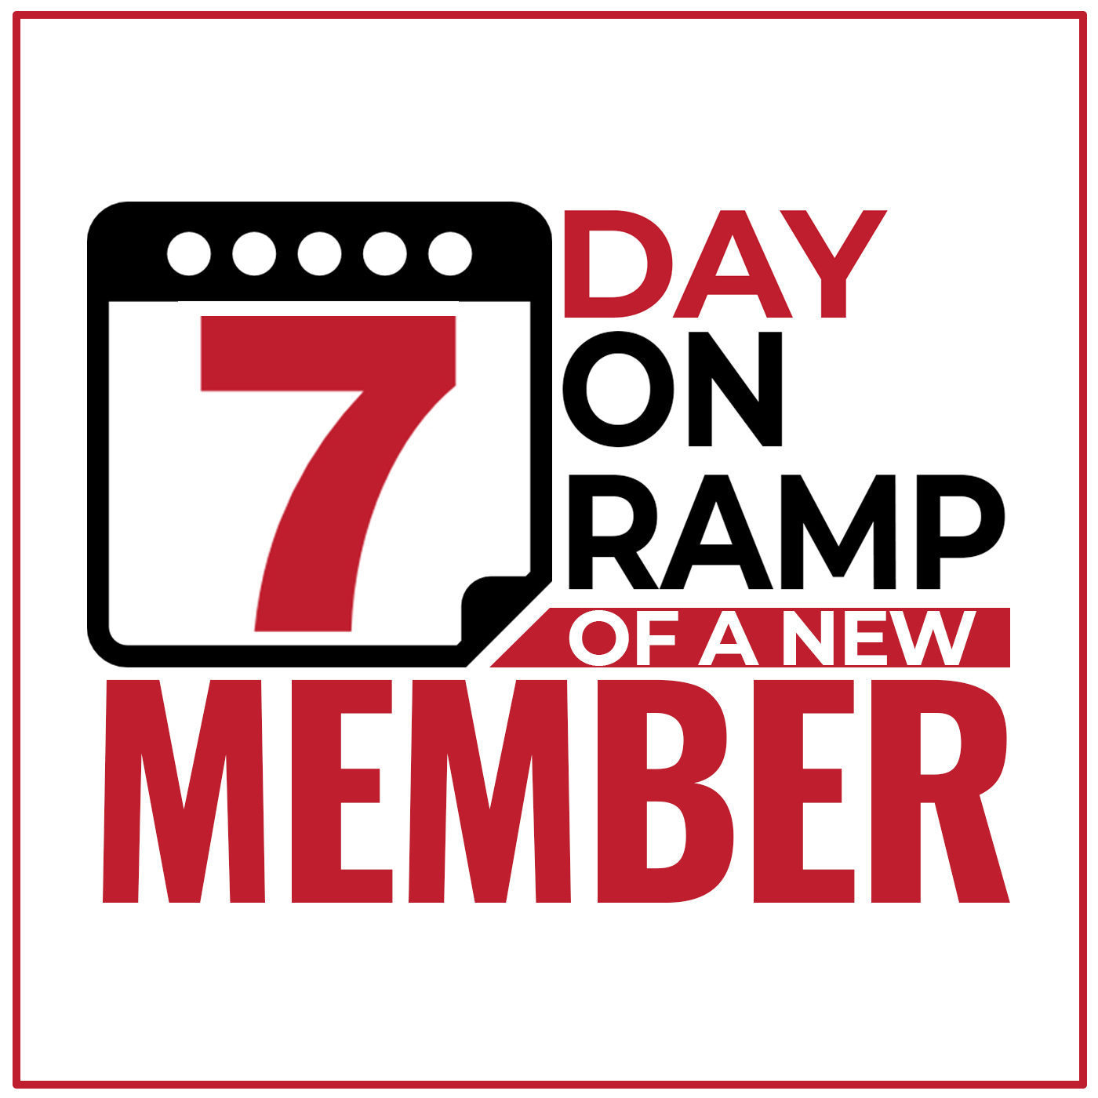
Checklist

1st Hour
- Immediate Welcome Email
- Receipt

1st Day
- Welcome Phone Call / Voicemail (If needed)
- Follow Up Email
Day after
- Welcome Phone Call / Voicemail (If needed)
- Follow Up Email

Welcome Package
- Welcome Letter
- “Your Package Has Shipped” Email

1st Week
- Second Welcome Phone Call / Voice Mail (If needed)
- Follow Up Email
- “Did You Get Your Package” Email

