RESPONSE EMAILS

These are the emails you send AFTER someone requests your freebie. Below you have Scott’s sample emails and a template that will further guide you. Please take these and make them your own, but do not share them with anyone else.

Email #1

Subject: Your FREE Membership Strategies Guide

Hey FIRST NAME,

Thank you for requesting your FREE copy of "Membership Multipliers: Seven Proven Strategies to Multiply Your Membership & Profits.”

Click here to download your FREE copy!

Since you requested this free resource, you may also be interested in getting a copy of my brand-new book, “Accelerate: How to Get Your Next 10, 100, 500 or Even 1,000 Members.”

You can get it for free, all I ask is that you cover the shipping and handling of just $7.95.

Others have found that the book goes into greater detail on how to add members to their membership every month.

Just like Steve Anderson, Founder of Workamper News…

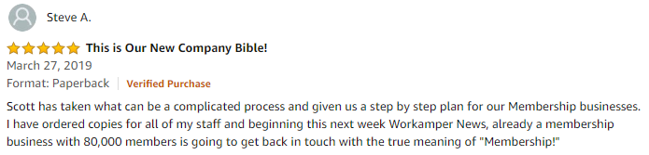

Click here to get your copy now!

Let’s accelerate your membership,

Scott

P.S. By the way, when you pick up a copy of the book, you’ll also get a free 30-day test drive of the Membership Accelerators Club. This is a private club where you’ll continue to get the marketing tools you need to grow your membership and get more prospects.

Click here to learn more!

Scott Whitaker,
Founder
www.MembershipMultipliers.com

TEMPLATE #1

Subject: Your FREE Membership Strategies Guide

Hey FIRST NAME,

Thank you for requesting your FREE copy of [insert the name of your freebie.]

Click here to download your FREE copy!

Since you requested this free resource, you may also be interested in [make an offer]. [Give them a reason to get it now.]

Others have found that the [insert benefit].

Just like [give a testimony]

Click here [have a call to action]

[sign]

P.S. [Give an added benefit to getting your resource/membership.]

[Call to action]

[your email signature]

Email #2

Subject: Just double checking. . .

Hey FIRST NAME,

I 'm just double checking that you received the email with your free "Membership Multipliers" Strategy Guide? I sent it about an hour ago.

If not you might check your spam folder or Click here to download your FREE copy!

Enjoy!

Scott

P.S. You also have an opportunity to get my brand-new book “Accelerate: How to Get Your Next 10, 100, 500 or Even 1,000 Members.” Plus, you can take a free test-drive of the Membership Accelerators Club all for just $7.95!

Click here to learn more!

Scott Whitaker,
Founder
www.MembershipMultipliers.com

TEMPLATE #2

Subject: Just double checking. . .

Hey FIRST NAME,

I 'm just double checking that you received the email with your free [insert the name of your freebie]? I sent it about an hour ago.

If not you might check your spam folder or Click here to download your FREE copy!

Enjoy!

Scott

P.S. [restate the offer from email #1]

[Call to action]

[signature block]

Email #3

Subject: Well, what did you think? (about your free strategy guide)

Hey FIRST NAME,

Just a quick email check-in... Did you read the free resource I sent you yesterday?

Hopefully you said "YES!", but if not PLEASE stop what you're doing and read it right now:

Click here to download your FREE copy!

"Could easily be sold for $10,000!"
Just saw this Amazon review of my brand-new book "Accelerate: How to Get Your Next 10, 100, 500, & Event 1,000 Members."

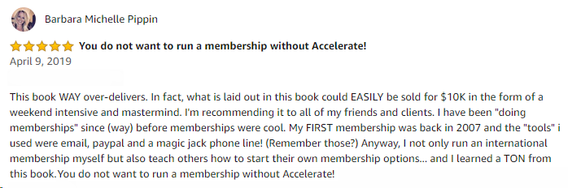

Would you like to get a free copy?

>> Click here and I'll give you a free copy!

You see, Michelle leads a membership just for women in business.

How did she get so big?

She's also a member of the Membership Accelerators Club and is using the tools and tips every month to get even more members.

It doesn't matter if you're just starting out, have 10, 100 or 500+ members, you'll get the tools you need to accelerate your membership.

Why am I giving away a free copy of my book?

There's not many practical tips, tools and books out there for people looking to get more members and increase retention. That's why for every person who picks up a copy, they're also going to receive one FREE month of the Membership Accelerators Club.

You'll get to join an elite group of membership marketers looking to grow their membership.

AccelerateMyMembership.com

Let's accelerate your membership!

Scott

P.S. Here's a peek inside of Accelerate, you'll discover my most closely guarded secrets for growing your membership, like...
- Page 14: What to do in the first hour in order to take a member from ‘Sign-up’ to ‘Fully-Engaged’ as fast as possible.
- Page 29: How to build an "Iron Fence" around your members so they want feel welcomed and safe in your community.
- Page 39: The 5-C Model of marketing and how it can help your grow your membership to numbers you wouldn't believe!
- Page 41: The secret to defining "Who is in your crowd" that no one is talking about but makes all the difference when you start promoting your group.
- Page 45: The one thing your MUST do to make your new members feel at home in your group so they never want to leave.
- Page 52: My secret formula for 10Xing members accountability. Nail this and you'll have a steady stream of income for years to come!
- Page 62: The three rules you must follow when someone wants to cancel your membership that will have them going from "I wanna quit" to "I'm so glad I stayed!"
- Page 73: The dreaded "C" word that all memberships hate and how you can easily overcome all of its pitfalls.
- Page 77: The two step process to retention rates so insane, you'll blink twice when you see the numbers!
- Page 86: How to use service opportunities within your membership to cement your relationship with your members and their relationships to each other.
- Page 88: The silent membership kill and what you can do to stop it from destroying your membership.
- Page 97: How to use an Engagement Tripwire to get your members actually using your membership and getting value out of it from Day 1.
- Page 101: The best all-time (but least used) method to multiply your membership and how you can do it over and over again to the same great result.
- AND SO MUCH MORE...

>> Get your free copy here!

Scott Whitaker,
Founder of Membership Multipliers

TEMPLATE #3

Subject: Well, what did you think? (about your free [your freebie])

Hey FIRST NAME,

Just a quick email check-in... Did you read the free resource I sent you yesterday?

Hopefully you said "YES!", but if not PLEASE stop what you're doing and read it right now:

Click here to download your FREE copy!

[Promote your resource you want them to buy]

Would you like to get [name of resource]?

>> [call to action]

[promote your resource]

[Call to action]

[Sign your email]

P.S. [Tell more about your resource]

You’ll also discover:
- [benefit bullet #1]
- [benefit bullet #2]
- [benefit bullet #3]
- [benefit bullet #4]

>> [Call to action]

[Sign your email]

Email #4

Subject: question...

Hey FIRST NAME,

Are you still interested in accelerating the growth of your membership?

Scott Whitaker,
Founder
www.MembershipMultipliers.com

TEMPLATE #4

Subject: question...

Hey FIRST NAME,

Are you still interested in [outcome you can provide]?

[signature]

https://ir337.infusionsoft.app/app/orderForms/15-Membership-Multipliers-adwords?ex=now+10
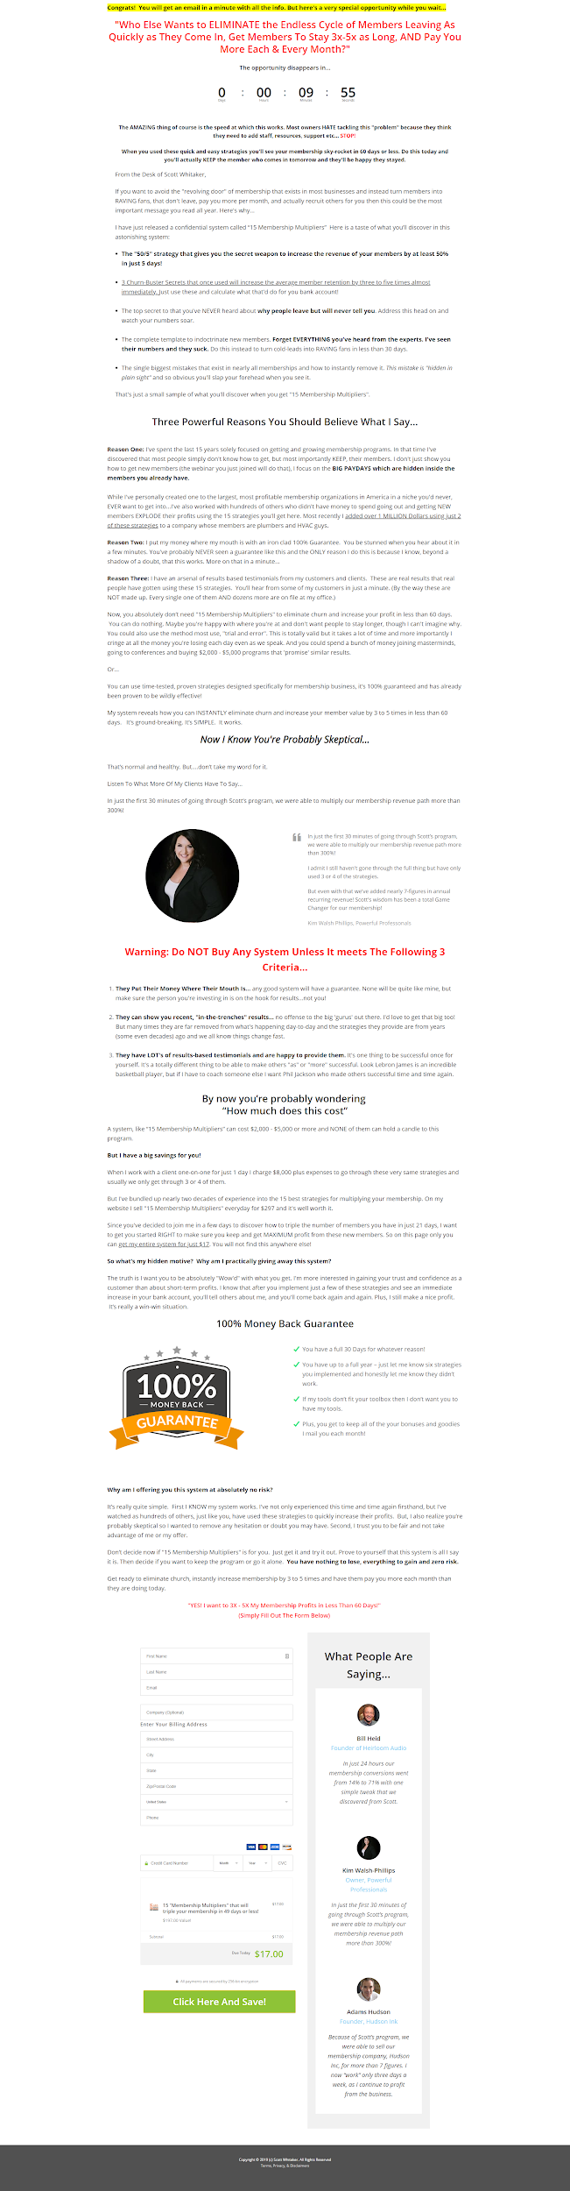

Giveaway Checklist
(Fill in the blanks for your giveaway)

1. Plan a date to run your giveaway.

My giveaway will run on (date) __________________________________________.

2. Decide your offer (first!)

My offer deadline date is ______________________________________________.

3. Have an offer that corresponds with your giveaway.

My offer is __________________________________________________________.

4. Build your sign-up page.

My sign up page URL is _______________________________________________.

5. Build your download page (with offer).

My download page URL is _____________________________________________.

6. Email follow-up campaign.

Email #1 Headline is __________________________________________________.

Email #2 Headline is __________________________________________________.

Email #3 Headline is __________________________________________________.

Email #4 Headline is __________________________________________________.

7. Marketing campaign with deadline.

My marketing deadline date is __________________________________________.

