SAMPLE FREEBIE SIGN-UP PAGE

Below is a sample webpage where you can sign up for a freebie. I give you this page as a model for your freebie.
https://scottwhitaker.lpages.co/membership-multipliers-free-strategy-guide-facebook-ad/

NOTE: The offer at the back of this page may have changed. But this page is still a good example of getting people to take your freebie.

SAMPLE SALES PAGE

Below is a sample sales page. There is a countdown timer on the page. It is best to open this link “incognito”. Otherwise, when the countdown runs out, you’ll be redirected to a different page.

A screenshot of the entire sales page is also included further below.

https://ir337.infusionsoft.app/app/orderForms/15-Membership-Multipliers-adwords?ex=now+10

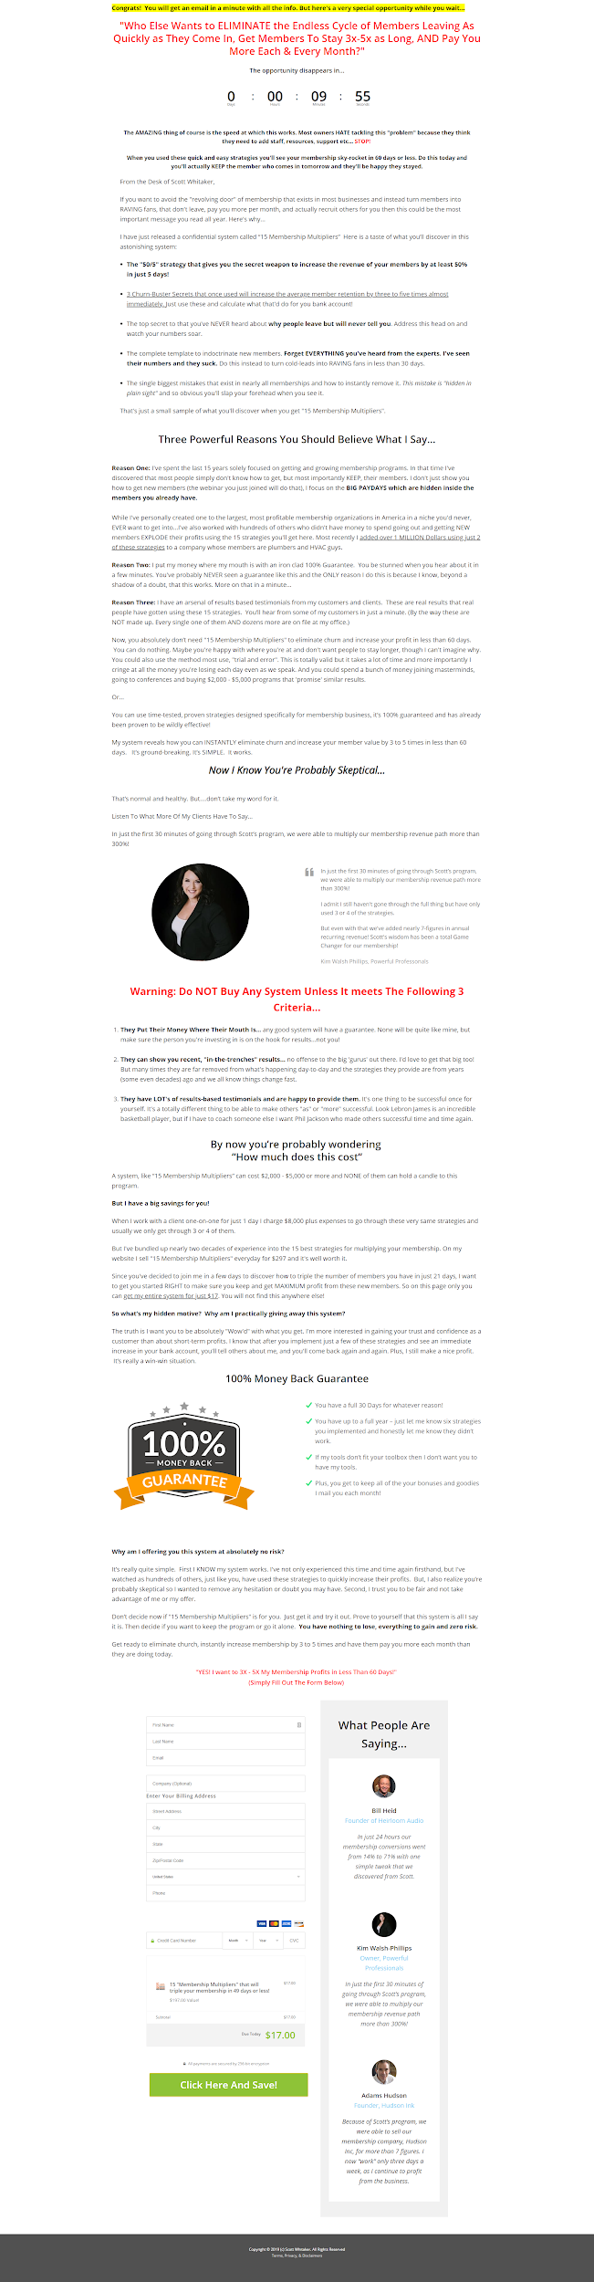

Giveaway Checklist
(Fill in the blanks for your giveaway)

1. Plan a date to run your giveaway.

My giveaway will run on (date) __________________________________________.

2. Decide your offer (first!)

My offer deadline date is ______________________________________________.

3. Have an offer that corresponds with your giveaway.

My offer is __________________________________________________________.

4. Build your sign-up page.

My sign up page URL is _______________________________________________.

5. Build your download page (with offer).

My download page URL is _____________________________________________.

6. Email follow-up campaign.

Email #1 Headline is __________________________________________________.

Email #2 Headline is __________________________________________________.

Email #3 Headline is __________________________________________________.

Email #4 Headline is __________________________________________________.

7. Marketing campaign with deadline.

My marketing deadline date is __________________________________________.

