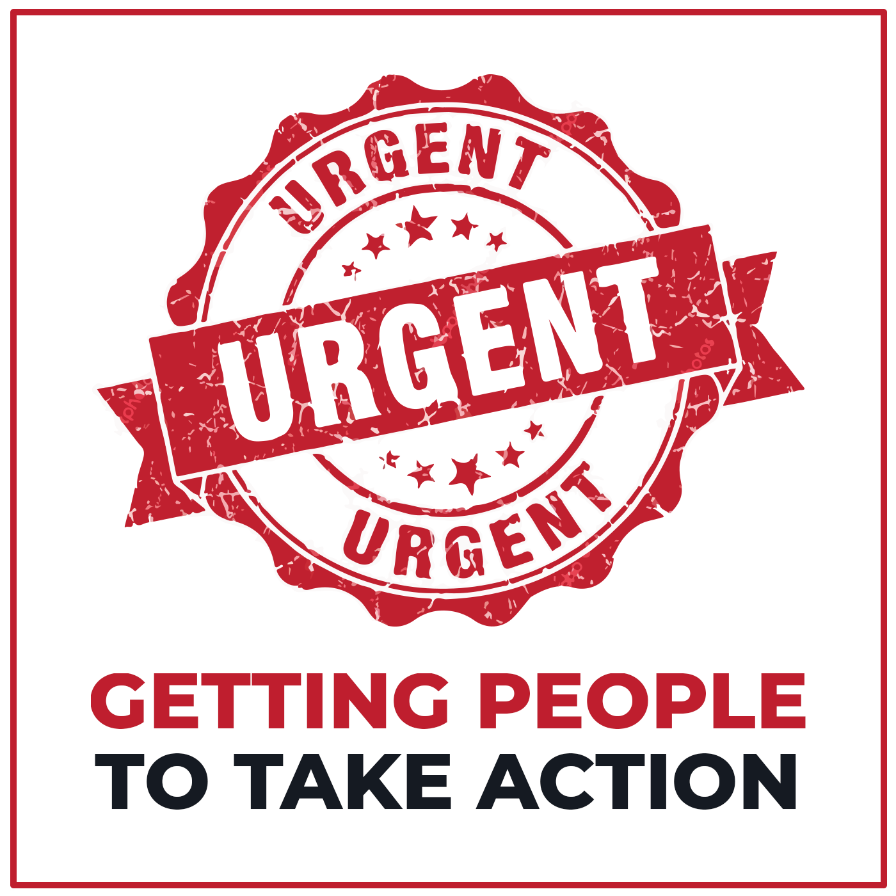

Get People to Take Action Now
Samples and Templates

Samples

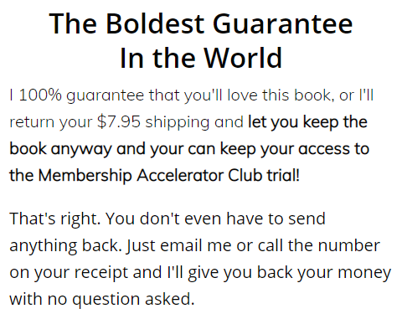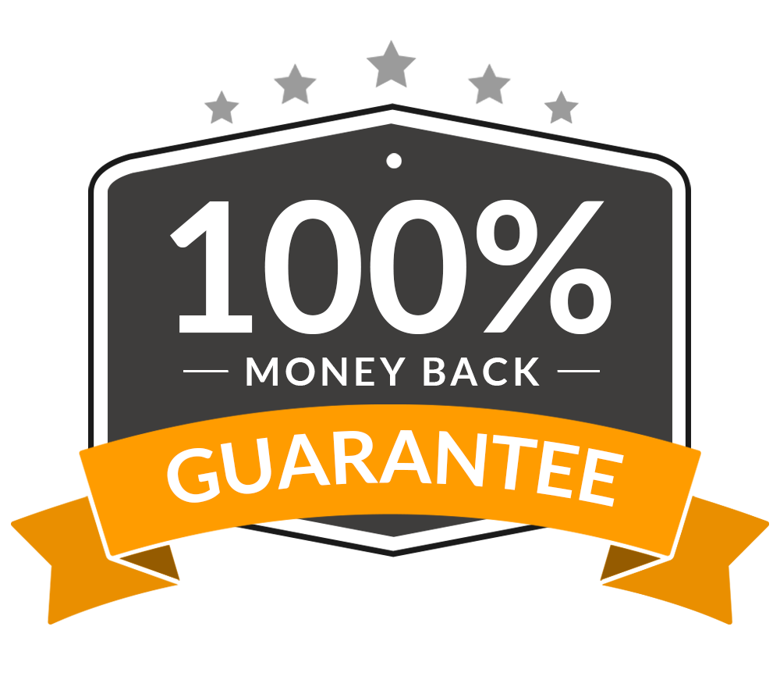

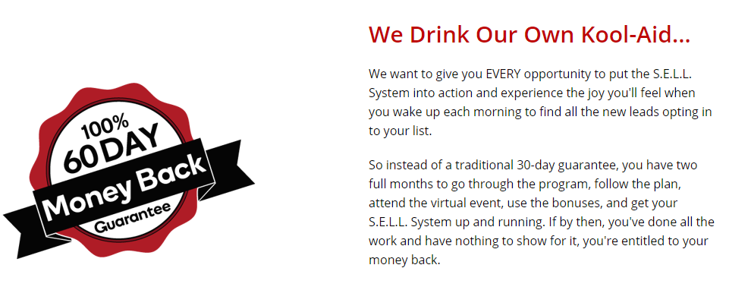

Templates

Copy

The Boldest Guarantee In The World

I 100% guarantee that you’ll love this [product or resource], or I’ll return your [investment price] and let you keep the [product] anyway and you can keep [bonus offer]!

That’s right. You dont even have to send anything back, just email me or call the number on your receipt and I’ll give you back your money with no question asked.

Graphics

Copy

We Drink Our Own Kool-Aid…

We want to give you EVERY opportunity to put the [product or resource] into action and experience the joy you’ll feel when you wake up each morning to find all the new leads opting in to your list.

So, instead of a traditional 30-day guarantee, you have two full months to go through the [product or resource step 1], [step 2], [step 3] use the bonuses, and [outcome of product or resource]. If by then, you’ve done all the work and have nothing to show for it, you’re entitled to your money back.

Graphics

