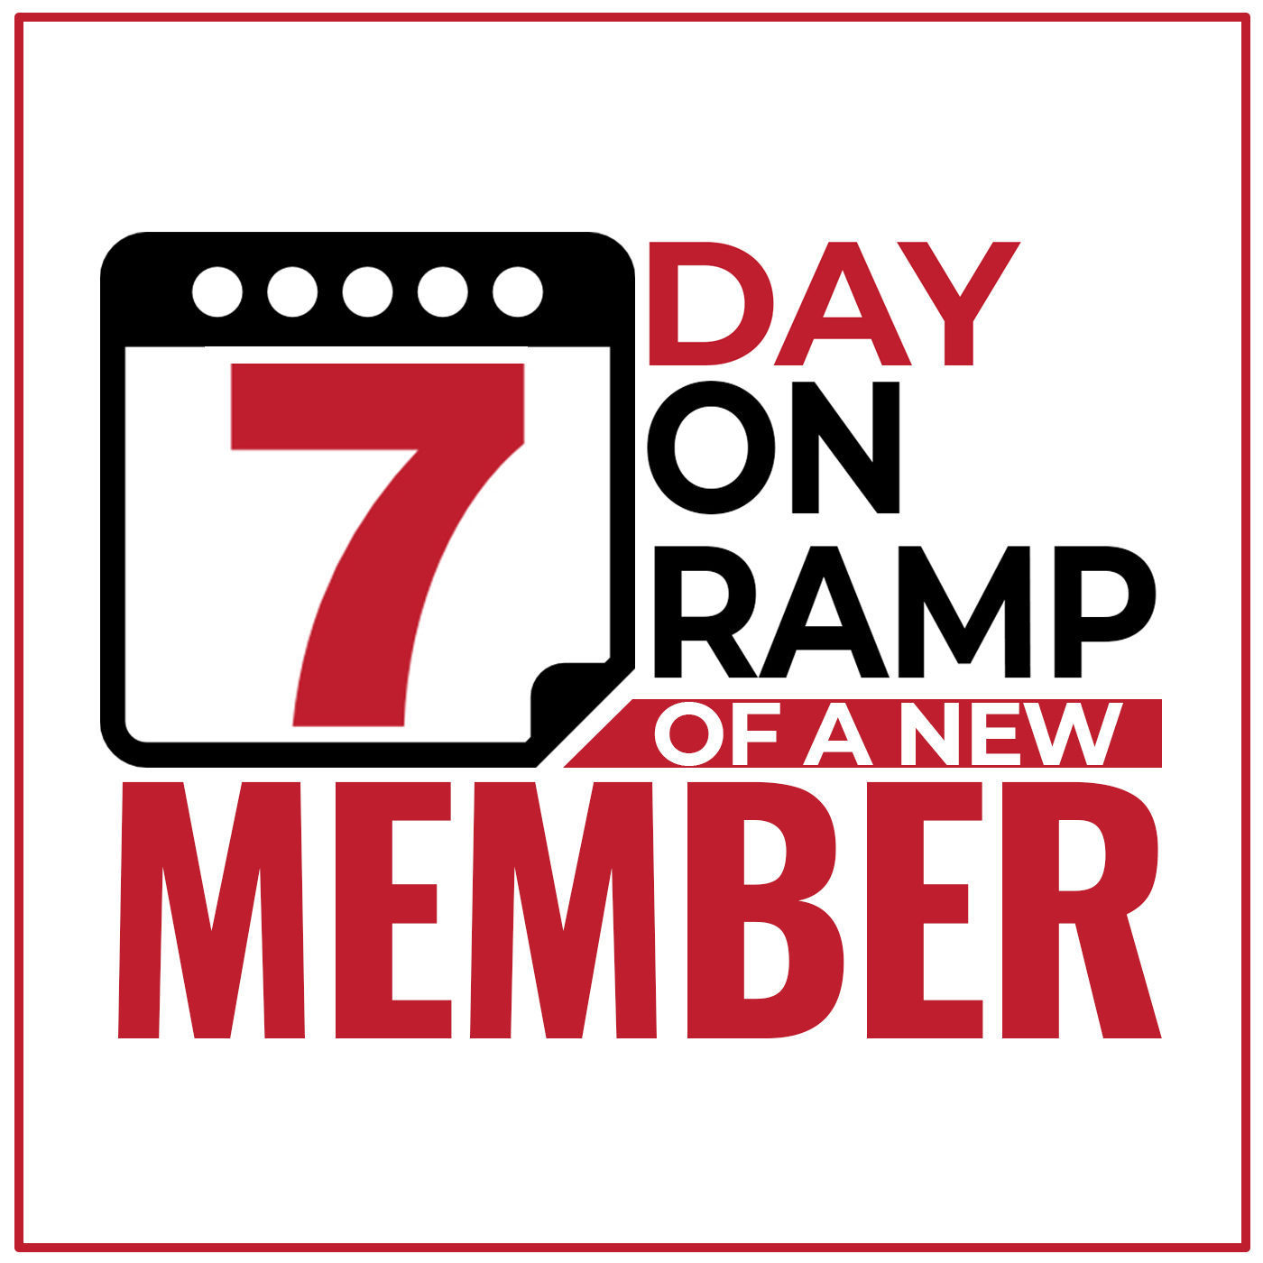
Welcome Letter

7 Day On Ramp Of A New Member
WELCOME LETTER
(Printed and sent with Welcome Package)

Let’s [VERB] Your Membership

Thank you for your [PRODUCT OR RESOURCE] order!
Enclosed is your copy of [PRODUCT OR RESOURCE TITLE]
Grab a pen and highlighter and get ready to mark up your book.
I highly suggest you check out:
- [BULLET POINT]
- [BULLET POINT]
- [BULLET POINT]
- [BULLET POINT]
- [BULLET POINT]
- [BULLET POINT]
- [BULLET POINT]
- [BULLET POINT]
- [BULLET POINT]
- [BULLET POINT]
- [BULLET POINT]
To help you even further, you’re receiving ONE FREE MONTH of the “[MEMBERSHIP NAME].”
If you haven’t already seen, there are a number of new trainings and tools that are coming soon. I want to help you and others “[SPECIFIC GOAL] Your Membership.”
Plus, you’ll continue to receive a member’s bonus kit every month. Yes, it’s a physical package that will be in the mail and sent to you every month.
Not to mention, there will be free gifts and goodies that I’ll send every now and then. After the 30 day test-drive, you will be billed [MEMBERSHIP MONTHLY PRICE] per month. You can cancel at any time. Most find that the club more than pays for itself.
Every month you’ll get a BRAND-NEW "[PRODUCT OUTCOME" like:
- [OUTCOME]
- [OUTCOME]
- [OUTCOME]
- [OUTCOME]
- [OUTCOME]
- And much, much more!
New tools and trainings are being added. Be sure to check it out.
Again, I look forward to helping you [SPECIFIC GOAL] your membership!
[IMAGE OF YOUR SIGNATURE]

[INSERT YOUR SIGNATURE]
ACTUAL EMAIL SAMPLE

Let’s “Accelerate” Your Membership

Thank you for your book order!
Enclosed is your copy of “How to Get Your Next 10, 100, 500 or Even 1,000 Members… And Why Most Membership Associations and Coaches Never Do!”
Grab a pen and highlighter and get ready to mark up your book.
I highly suggest you check out:
- Page 14: What to do in the first hour in order to take a member from ‘Sign-up’ to ‘Fully-Engaged’ as fast as possible.
- Page 29: How to build an "Iron Fence" around your members so they will feel welcomed and safe in your community.
- Page 39: The 5-C Model of marketing and how it can help grow your membership to numbers you wouldn't believe!
- Page 41: The secret to defining "Who is in your crowd" that no one is talking about but makes all the difference when you start promoting your group.
- Page 45: The one thing your MUST do to make your new members feel at home in your group so they never want to leave.
- Page 52: My secret formula for 10Xing members’ accountability. Nail this and you'll have a steady stream of income for years to come!
- Page 62: The three rules you must follow when someone wants to cancel your membership that will have them going from "I wanna quit" to "I'm so glad I stayed!"
- Page 73: The dreaded "C" word that all memberships hate and how you can easily overcome all of its pitfalls.
- Page 77: The two-step process to retention rates so insane, you'll blink twice when you see the numbers!
- Page 86: How to use service opportunities within your membership to cement your relationship with your members and their relationships to each other.
- Page 88: The silent membership killer and what you can do to stop it from destroying your membership.
- Page 97: How to use an Engagement Tripwire to get your members actually using your membership and getting value out of it from Day 1.
- Page 101: The best all-time (but least used) method to multiply your membership and how you can do it over and over again with the same great result.

To help you even further, you’re receiving ONE FREE MONTH of the “Membership Accelerators Club.”
If you haven’t already seen, there are a number of new trainings and tools that are coming soon. I want to help you and others “Accelerate Your Membership.”
Plus, you’ll continue to receive a member’s bonus kit every month. Yes, it’s a physical package that will be in the mail and sent to you every month.
Not to mention, there will be free gifts and goodies that I’ll send every now and then. After the 30 day test-drive, you will be billed $99 per month. You can cancel at any time. Most find that the club more than pays for itself.
Every month you’ll get a BRAND-NEW "Membership Accelerator" like:
- Simple "marketing triggers" and a complete checklist to increase your marketing effectiveness (so that you never leave your marketing to chance)
- The 4xT "Membership Accelerator" to increase membership referrals from both your current members and even your non-members.
- How to get more prospects so that you're constantly moving people from "interest" to membership.
- Engagement tripwires so that you can measure the engagement of your members and increase your retention.
- "Cancellation Stoppers" to keep people from quitting your membership (giving you a greater opportunity to help them!)
- 19 places to find your ideal members. Go through this and the battle is already half way won.
- The “Never-Been-Easier” 10 Line Offer Formula so once you’ve attracted leads, you effortlessly turn them into cash-paying members.
- And much, much more!
New tools and trainings are being added. Be sure to check it out.
Again, I look forward to helping you accelerate your membership!


Scott Whitaker,
Founder
www.MembershipMultipliers.com

